Forecasting Great Britain’s daily peak electricity demand, 2009–2024

1 Introduction
Great Britain’s transmission network has to predict and prepare for the highest demand periods of the year [1]. Underestimating these peaks would underprepare infrastructure for harsh winter weather. Whereas overestimating them could drive higher energy prices. This report models the daily peak of National Demand and answers two important questions. Firstly, to what extent could the daily variation in demand be explained by a calendar-based structure? Secondly, would applying additional time-series modelling to the remaining variation further improve the accuracy of peak forecasts?
Energy forecasting is a well-established field with the standard toolkit including various methods, including regression on calendar and weather variables, Fourier terms for seasonality, and dynamic regression for what the predictors miss out [2]. The same methods can be applied here. The first is harmonic regression, for the annual cycle including Fourier terms [3], with inference robust to the heteroskedasticity and autocorrelation from daily energy data [4], an omnibus test for categorical predictors, and a pre-specified sensitivity analysis. The second is time-series analysis, including Seasonal and Trend decomposition using LOESS (STL) [5], unit-root and stationarity testing, and regression with ARIMA errors. Forecast accuracy is evaluated on a rolling-origin design.

2 Objectives and methodology

Research question
To what extent can the daily variation in Great Britain’s peak transmission demand be explained by a small, prespecified set of calendar and embedded-generation predictors?
Once those effects are accounted for, does modelling the remaining time-series structure improve forecasts compared with both the calendar model alone and seasonal-naive benchmarks at short horizons?

Pre-specification
The predictors were fixed in advance, including a linear trend, annual Fourier harmonics, a day-of-week factor, and a public-holiday indicator. That leaves room for one tuning parameter, the number of annual harmonics K, and one rule for setting it. Take the largest K before the next harmonic adds less than 0.002 to adjusted R-squared, and apply that rule to the training period only. The report did not use an information criterion for this. With roughly 5,500 training days, AICc continues to decrease even when further improvements are practically negligible [6], [7].
Day-of-week is tested using a single omnibus F-test. Six post-hoc weekday contrasts are not employed, to avoid multiple comparison problems [8], [9]. Effect sizes come with intervals rather than a p-value [10]. Embedded solar capacity appears only in the descriptive analysis. It is kept out of the forecasting modelling for two reasons, which are that it is not a clean ex-ante input at short horizons, and that it is collinear with the long-run trend.

Leakage-free forecast evaluation
For evaluation, no model should bring in any factors outside of the forecast origin. Ordinary k-fold cross-validation breaks that rule by construction, because shuffling observations lets later data inform earlier predictions [11]. Cross-validation can be rescued for autoregressive models, but only when the residuals are uncorrelated [12], which Section 4.3 shows is not the case here. Evaluation on a rolling forecast origin is the protocol that survives that objection [13].
The training set ends on 31 December 2023. At each rolling origin, the models are refitted using only the data available up to that point. For the dynamic model, the ARIMA(3,0,1) error structure remains fixed throughout. That is the distinction between updating a model’s parameters as the origin advances and re-specifying the model itself [13]. Re-selecting the order at all 45 origins would leave 45 different models being compared rather than one model across 45 windows.
Calendar predictors are known in advance and are included in the forecast. They are deterministic functions of the date, so they carry no forecast error of their own at any lead time. No future weather or solar value is used anywhere.
The main evaluation uses weekly forecast origins throughout 2024, with predictions made up to 30 days ahead. Because these 30-day forecast windows overlap, the resulting errors are not independent and are used to describe forecasting performance rather than for formal hypothesis testing. Errors at h steps ahead are serially correlated even when a model is correctly specified [15], and a formal comparison would need a procedure built for correlated forecast errors with a small-sample correction for the overlap [16]. As a secondary check, the models are also evaluated from a single fixed origin on 31 December 2023, since a fixed-origin result depends heavily on the one origin chosen [13]. Accuracy is reported as mean absolute error (MAE), root-mean-square error (RMSE) and mean absolute scaled error (MASE), with MASE scaled by the in-sample MAE of a 7-day seasonal naive on the history available at that origin [17]. Computing that denominator per origin rather than once across the whole series keeps it free of holdout information.

3 Data
The dataset comes from the National Grid ESO’s Historic Demand Data [19], taken from the openly licensed Kaggle compilation Electricity consumption UK 2009–2024 [20]. It contains one row for each half-hour settlement period, covering 5,818 consecutive days from 1 January 2009 to 5 December 2024. The main variable is National Demand (nd), measured in megawatts. This represents the energy amount that the transmission system must meet rather than that consumed directly by end users. The dataset also records estimated embedded, or distribution-connected, solar generation and installed capacity, along with a public-holiday indicator. Embedded solar is not directly metered by the system operator, so installed capacity is estimated from publicly available sources, not observed directly [21].
Some cleaning was required before the data could be analysed consistently [22]. Both the column headers and the date format change halfway through the record, so two formats were parsed separately and reconciled into a single date variable. Days when the clock changes carry 46 or 50 settlement periods instead of 48. As such, to achieve the daily maximum demand, all available settlement periods were retained.
The half-hours are then collapsed to one row per day, with peak demand and maximum embedded solar capacity in gigawatts, the weekday, the holiday indicator, and a linear trend. Annual Fourier terms are built on continuous elapsed time, allowing the seasonal cycle to continue smoothly across year boundaries instead of resetting each January. The holiday indicator is directly extracted from the dataset, marking 131 days across the sixteen years.
The final training set contains 5,478 daily observations in 2009-2023. The holdout set contains 340 observations from 2024, ending abruptly on 5 December 2024. Thus, the evaluation period does not include the colder final weeks of December.
Table 1. Variables used in the peak-demand models.
Variable | Meaning
peak_gw (derived) | Daily maximum National Demand, GW. The outcome variable
trend | Elapsed years since 1 Jan 2009, a linear time trend
s1..c3 (derived) | Annual Fourier sine/cosine pairs at 1x, 2x and 3x the yearly frequency
wday | Day-of-week factor, Monday to Sunday
is_holiday / hol | Public-holiday flag supplied with the dataset (England and Wales)
solar_cap_gw | Day’s maximum embedded solar capacity, GW (descriptive model only)

4 Results

4.1 Calendar structure explains most of the movement
The elbow rule, which is applied to the training data alone, settles on K = 3 annual harmonics. Adding the third harmonic increased adjusted R-squared by 0.0098, whereas the fourth added only 0.0017, falling below the predefined threshold of 0.002 (Table 2). From there, the descriptive model reaches an adjusted R-squared of 0.929, indicating that calendar structure, together with the descriptive solar term, accounted for approximately 93% of the daily variation in peak demand. Figure 1 shows the fitted trend-plus-seasonal curve running through sixteen years of raw data, while also revealing a gradual decline in peak demand beneath the seasonal swing.
Table 2. Fourier-order selection on the 2009–2023 training data. The rule stops at the largest K before the gain in adjusted R-squared falls below 0.002.
K | Adj. R2 | Delta adj. R2 | AICc
1 | 0.9156 | NA | 23777.43
2 | 0.9184 | 0.0028 | 23597.60
3 | 0.9282 | 0.0098 | 22900.48
4 | 0.9299 | 0.0017 | 22770.37
5 | 0.9307 | 0.0008 | 22708.36
6 | 0.9326 | 0.0019 | 22562.00
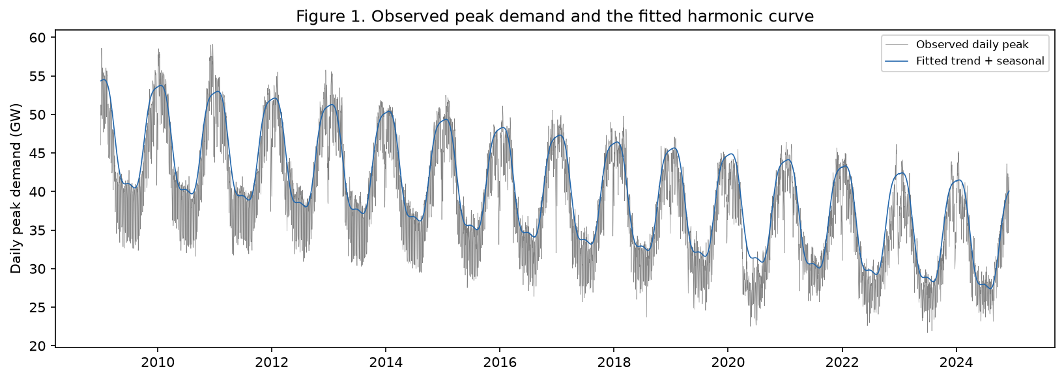
Figure 1. Daily peak National Demand, 2009–2024 (grey), with the fitted trend-plus-seasonal curve from the descriptive harmonic regression (blue). The curve holds weekday and holiday effects at their reference level, a non-holiday Monday.

4.2 Robust effect sizes
Using Newey-West robust standard errors [4], the model estimates the decline at about 0.76 GW per year on average, with a 95% interval of 0.65 to 0.87 (Table 3). That is consistent with the broader decarbonisation period in British electricity demand [23].
A quadratic-trend sensitivity, specified in advance and not part of the forecasting specification, improves AIC from 24,324 to 24,285 with a curvature term of -0.010 GW/yr², which points to the decline getting slightly steeper over time.
The calendar effects are substantial and unsurprising in direction. Relative to an equivalent Monday, peak demand was approximately 5.29 GW lower on public holidays, 5.03 GW lower on Saturdays, and 4.68 GW lower on Sundays. Day of week was strongly significant as a group (F(6,5802)=1065, p<0.001). Embedded solar capacity carries a small negative coefficient (-0.10 GW per GW, p = 0.019). It correlates 0.96 with time, making it difficult to separate its effect from the long-term trend. Additionally, winter peak demand typically occurs in the evening, when solar generation is negligible or zero.
Table 3. Descriptive peak-demand model with robust Newey-West 95% intervals. Baseline is a non-holiday Monday in 2009.
Effect | Effect (GW) | 95% CI (GW) | p
Trend, per year | -0.76 | -0.87 to -0.65 | <0.001
sin(1x annual) | 0.43 | 0.24 to 0.62 | <0.001
cos(1x annual) | 7.49 | 7.29 to 7.69 | <0.001
sin(2x annual) | 0.11 | -0.06 to 0.29 | 0.208
cos(2x annual) | 0.52 | 0.30 to 0.73 | <0.001
sin(3x annual) | 0.07 | -0.11 to 0.26 | 0.442
cos(3x annual) | -1.00 | -1.20 to -0.81 | <0.001
Tuesday vs Monday | -0.09 | -0.20 to 0.02 | 0.100
Wednesday vs Monday | -0.18 | -0.30 to -0.06 | 0.003
Thursday vs Monday | -0.38 | -0.51 to -0.26 | <0.001
Friday vs Monday | -1.42 | -1.56 to -1.29 | <0.001
Saturday vs Monday | -5.03 | -5.18 to -4.89 | <0.001
Sunday vs Monday | -4.68 | -4.85 to -4.52 | <0.001
Public holiday | -5.29 | -5.92 to -4.65 | <0.001
Embedded solar capacity, per GW | -0.10 | -0.18 to -0.02 | 0.019

4.3 Residual diagnostics
Although the descriptive model explains most of the observed variation, its residuals are clearly not white noise. While Breusch-Godfrey rejects independence [24], Breusch-Pagan rejects constant variance [25] (Table 4). At the same time, the augmented Dickey-Fuller test rejects a unit root [26], and KPSS does not reject level stationarity (statistic 0.249, p = 0.100) [27]. So the residuals are stationary but heavily autocorrelated, which is precisely the case for which regression with ARIMA errors was built [28].
Figure 2 shows the dependence directly. The residual autocorrelation function starts at 0.73, and decays slowly across all 30 displayed lags. That decay is not monotone. It flattens through the sixth and seventh lags and lifts again around the fourteenth (0.44 and 0.24 respectively), a weekly echo suggesting that the weekday indicators do not capture all of the weekly dependence. Multiple overlapping seasonal cycles are common in electricity demand data [29]. The partial autocorrelation, however, falls sharply after the first lag and remains close to zero thereafter. Together, these patterns suggest a relatively low-order autoregressive process with an additional moving-average component. The ARIMA error structure used in Section 4.4 was therefore guided by the residual ACF and PACF patterns, rather than chosen solely by an automated model search.
Table 4. Residual diagnostics and stationarity tests on the descriptive model.
Test | Statistic | p
Breusch-Godfrey (7 lags) | 3402.14 | <0.001
Breusch-Pagan | 589.79 | <0.001
Augmented Dickey-Fuller | -13.16 | <0.01
KPSS (level) | 0.249 | 0.100
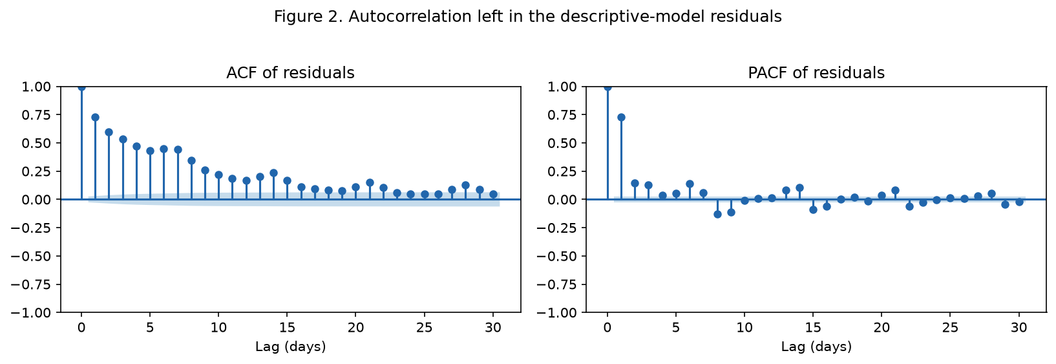
Figure 2. Autocorrelation and partial autocorrelation of the descriptive-model residuals, thirty lags. The slow ACF decay with a sharp PACF cut-off motivates a low-order ARIMA error structure [28].
In Figure 3, the STL decomposition breaks the series into trend, weekly seasonality, and a remainder. The remainder shows the stationary but autocorrelated variation that the dynamic model is designed to capture.
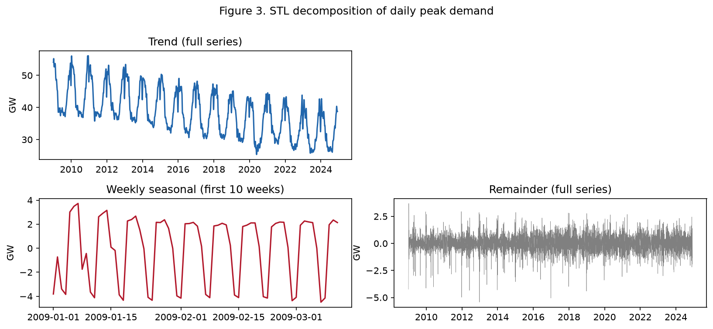
Figure 3. STL decomposition of daily peak demand at the weekly period. Top: the trend component over the full series, which absorbs both the annual cycle and the multi-year decline. Bottom left: the weekly seasonal component, adjusting to ten weeks for legibility. Bottom right: the remainder, showing the stationary but autocorrelated variation modelled by the dynamic specification.

4.4 Rolling-origin forecast
The dynamic model uses an ARIMA(3,0,1) error structure, reestimated at each of the 45 rolling origins. However, this would not be the order selected by a full AICc grid over ((p,0,q)), with (p) and (q) ranging from 0 to 3, as commonly used for automatic order selection [30]. The minimum is ARIMA(3,0,3), and it sits 255 AICc units below ARIMA(3,0,1). Taken at face value, this would suggest a clear preference for ARIMA(3,0,3).
Only 10 of the 16 fits reported convergence, and ARIMA(3,0,3) was not among them. Neither was ARIMA(3,0,1). As such, neither could technically be selected. However, what the converged fits do show is a flat surface. The best converged specification, ARIMA(1,0,3), lands at 17,936.01 against 17,935.59 for ARIMA(3,0,1), a difference of less than one unit. Thus, the better ARIMA(3,0,3) result comes from a model whose optimiser did not converge.
Thus, we keep ARIMA(3,0,1). The order was specified before examining the holdout period, it is broadly consistent with the residual ACF and PACF patterns in Figure 2, and its AICc lay effectively at the floor of the stable region of the grid. It is also the leaner specification, with two fewer moving-average terms than ARIMA(3,0,3). This comes to matter when the same order has to be reestimated on 45 different training windows.
Forecast accuracy depends heavily on lead time (Table 5). At one day ahead, the dynamic regression performs best, at MASE 0.69 compared with 0.88 for the strongest benchmark. It stays marginally ahead over 2–7 days, although the gap over the 364-day seasonal naive narrows down. Beyond one week, the ranking changes. From 8-30 days, the 364-day seasonal naive performs best. Once the calendar effects are in the model, explicitly modelling residual dependence therefore provides little additional benefit at these longer horizons. Seasonal-naive benchmarks are strong competitors for demand series of this kind, and evaluations that omit them tend to overstate what the more elaborate model contributes [31]. Figure 4 demonstrates this change in relative performance.
Table 5. Primary rolling-origin accuracy over weekly 2024 origins (GW; MASE unitless). Lower is better, each block ordered best first.
Horizon | Model | MAE | RMSE | MASE
1 day | Dynamic regression | 1.17 | 1.41 | 0.69
1 day | 364-day seasonal naive | 1.50 | 2.02 | 0.88
1 day | Harmonic regression | 1.59 | 2.03 | 0.93
1 day | Weekly seasonal naive | 2.02 | 2.78 | 1.19
2-7 days | Dynamic regression | 1.30 | 1.66 | 0.77
2-7 days | 364-day seasonal naive | 1.35 | 1.81 | 0.80
2-7 days | Harmonic regression | 1.63 | 1.99 | 0.96
2-7 days | Weekly seasonal naive | 1.68 | 2.18 | 0.99
8-30 days | 364-day seasonal naive | 1.34 | 1.81 | 0.79
8-30 days | Dynamic regression | 1.47 | 1.87 | 0.87
8-30 days | Harmonic regression | 1.59 | 1.98 | 0.94
8-30 days | Weekly seasonal naive | 2.65 | 3.42 | 1.56
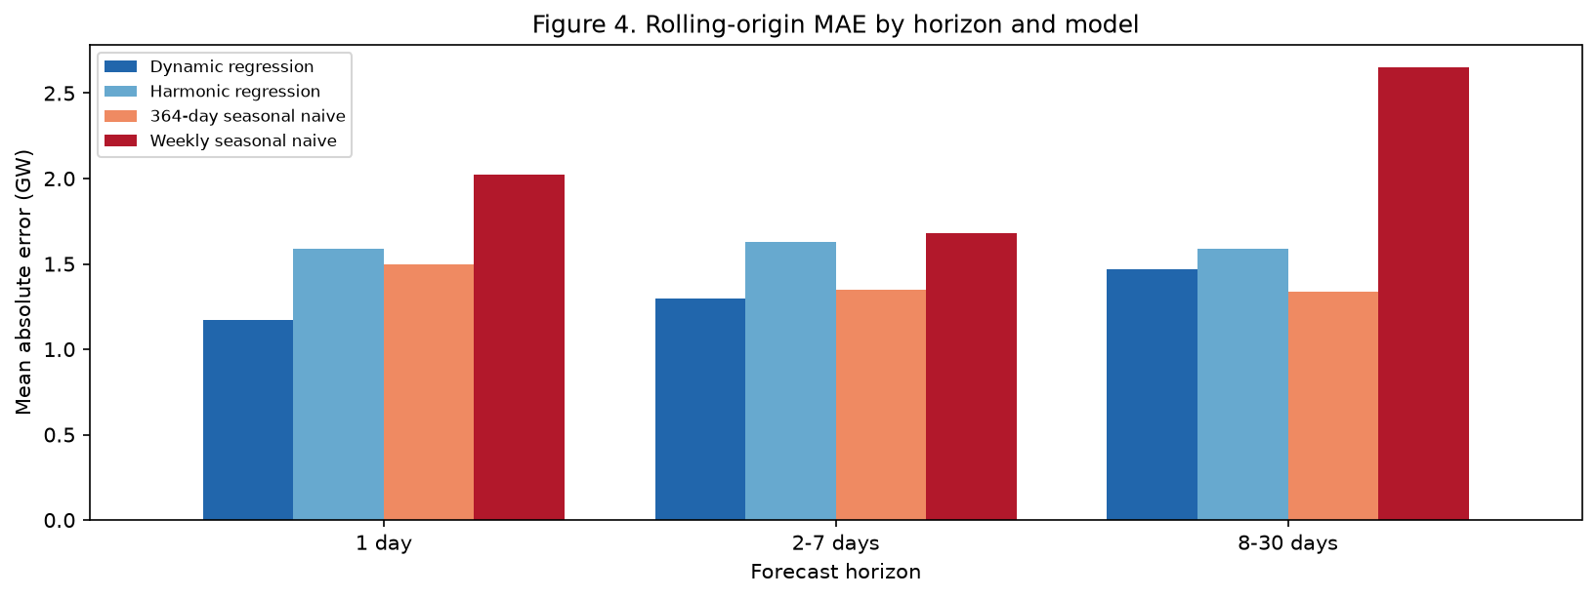
Figure 4. Rolling-origin mean absolute error by horizon and model, weekly 2024 origins.
Figure 5 illustrates the same effect for the first 30-day forecast window from the first origin. For the first two days, the dynamic regression sits almost on top of the actual series. As the forecast horizon increases, however, the ARIMA component gradually loses the information contained in the most recent observations. Its forecast therefore moves back towards the underlying harmonic regression, and by the end of January the two model paths are almost indistinguishable. That is the horizon effect in one picture.
The same example also shows a limitation shared by both regression models. Demand rises sharply during the second week of January to 45.2 GW on 15 January 2024, but both models underestimate that peak, by 5.1 GW for the dynamic regression and 3.9 GW for the harmonic. Calendar variables can identify where a day falls within the week or year, but they cannot capture an unusually cold spell when temperature is absent from the model. Section 5 further inspects this.
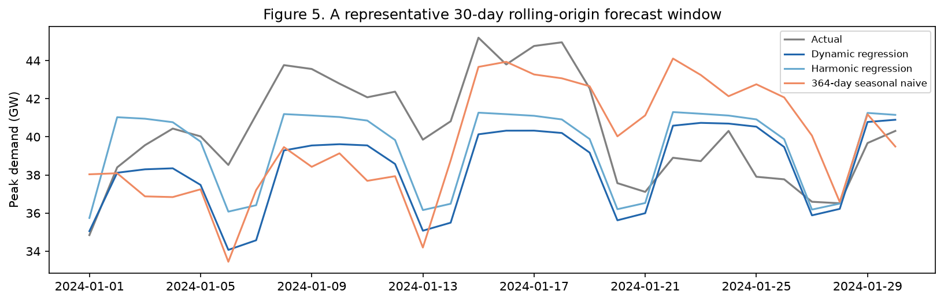
Figure 5. A representative 30-day rolling-origin forecast window from the first origin.
The secondary stress test forecasts all of 2024 from a single origin at the end of 2023 (Table 6). Here, the plain harmonic regression is most accurate at short range, the dynamic regression performs less well, while the 364-day seasonal naive does best at longer horizons. So the two designs disagree about which model wins at 1–7 days. For the intended forecasting, greater weight should be given to the rolling-origin evaluation. Forecasting a full year from one origin does not closely resemble operational grid forecasting, where predictions are repeatedly updated as new observations become available [13]. Despite their differences, both agree on the conclusion that matters, which is that modelling the residual dynamics adds useful predictive information only at the shortest horizons.
Table 6. Secondary fixed-origin accuracy on the 2024 holdout (GW; MASE unitless), forecasting the whole year from 31 December 2023.
Horizon | Model | MAE | RMSE | MASE
1-7 days | Harmonic regression | 1.82 | 2.34 | 1.08
1-7 days | Dynamic regression | 2.49 | 3.29 | 1.47
1-7 days | 364-day seasonal naive | 3.08 | 3.37 | 1.83
1-7 days | Weekly seasonal naive | 6.24 | 6.38 | 3.70
8-30 days | Harmonic regression | 2.22 | 2.53 | 1.32
8-30 days | Dynamic regression | 2.76 | 3.19 | 1.63
8-30 days | 364-day seasonal naive | 2.95 | 3.44 | 1.75
8-30 days | Weekly seasonal naive | 8.18 | 8.85 | 4.85
31+ days | 364-day seasonal naive | 1.35 | 1.84 | 0.80
31+ days | Dynamic regression | 1.63 | 2.01 | 0.97
31+ days | Harmonic regression | 1.65 | 2.04 | 0.98
31+ days | Weekly seasonal naive | 4.57 | 5.38 | 2.71

5 Limitations
No weather. Temperature is the largest missing predictor and probably drives much of the residual autocorrelation. Using observed weather would give the model information that was not available when the forecast was made. A proper out-of-sample evaluation would therefore need archived weather forecasts from each forecast origin rather than the weather observed afterwards [32]. Otherwise, future information would leak into the model and undermine the purpose of the rolling-origin evaluation [11]. Weather is also known to have a strong influence on electricity demand and system behaviours [33].
Collinearity and measurement. Embedded solar capacity highly correlates with time (r=0.96) and is an estimate rather than a metered value. Therefore, its coefficient should be treated as an association only, not as causal effect. It stays out of the forecasting models.
Holiday calendar. The flag follows England and Wales’ calendar rules while demand covers Great Britain as a whole. Thus, some Scottish holidays are mislabelled: the August bank holiday is marked on the last Monday rather than the first Monday observed in Scotland, and 2 January is unmarked except in years where it substitutes for New Year’s Day. Moved holidays deserve the same scrutiny. An earlier version of this analysis maintained the calendar as a separate file and lost 4 June 2012, the Spring bank holiday displaced that year to sit beside the Diamond Jubilee. The indicator is now read directly from the dataset, so that particular error cannot recur, but the episode shows how much a single day can matter when a public holiday moves the daily peak by around 5.29 GW.
Incomplete holdout. The 2024 data stops on 5 December 2024 and misses the late December peaks. These days can contain some of the year’s highest winter demand and are particularly important for capacity planning.
Central forecasts only. These models forecast the conditional centre of daily peaks, which is useful for comparing point-forecast accuracy. But it does not address planning for system stress. This requires annual extremes, upper quantiles or prediction intervals, none of which are produced here [14].
Overlapping windows. Weekly origins with 30-day horizons are useful operationally but are not independent. Consequently, the resulting accuracy measures are better treated as comparative summary of forecasting performance. They do not hold the same value as independent observations for formal hypothesis tests [15], [16].
Optimiser convergence. Maximum-likelihood estimation of the ARIMA error structure raises convergence warnings at most origins. Only 10 of the 16 fits in the order grid converged cleanly. Forecasts are still produced from the fitted parameters at every origin, and the accuracy results are consistent across all 45 of them. The conclusions of this report rely on comparative forecast performance rather than on the standard errors of ARIMA coefficients. A more extensive run could improve by allowing for longer optimisation, better starting values, or a state-space formulation less prone to flat likelihood surfaces [35].

6 Conclusion
Four fixed calendar predictors could explain most of the daily variation in Great Britain’s peak transmission demand, including a linear trend, three annual harmonics, day-of-week effects, and a public-holiday indicator, achieving an adjusted R-squared of 0.929. Peak demand fell by roughly 0.76 GW yearly in 2009-2024, and the fall has been getting slightly steeper. Weekends and holidays’ demand sits several gigawatts below ordinary weekdays. What is left after accounting for these effects is stationary but still autocorrelated.
Forecasting results show that this residual dependence is useful only over relatively short horizons. Under leakage-free rolling-origin evaluation, the dynamic regression is useful one day ahead, at MASE 0.69 against 0.88 for the best benchmark. Its advantage shrinks over 2–7 days and is gone by 8–30 days, where a 364-day seasonal naive does better than anything more sophisticated. It is practical to pick the model by forecast lead time and keep the cheap benchmark in the comparison, because at longer horizons it is not a baseline against which more complex models are judged, but the best-performing forecast in this analysis.

References
[1] UK Department for Energy Security and Net Zero, “Statutory security of supply report.” gov.uk, 2025. Available: https://www.gov.uk/government/publications/statutory-security-of-supply-report-2025
[2] R. J. Hyndman and G. Athanasopoulos, Forecasting: Principles and practice, 3rd ed. Melbourne, Australia: OTexts, 2021. Available: https://otexts.com/fpp3/
[3] P. Bloomfield, Fourier analysis of time series: An introduction, 2nd ed. New York: Wiley, 2000. doi: 10.1002/0471722235.
[4] W. K. Newey and K. D. West, “A simple, positive semi-definite, heteroskedasticity and autocorrelation consistent covariance matrix,” Econometrica, vol. 55, no. 3, pp. 703–708, 1987, doi: 10.2307/1913610.
[5] R. B. Cleveland, W. S. Cleveland, J. E. McRae, and I. Terpenning, “STL: A seasonal-trend decomposition procedure based on loess,” Journal of Official Statistics, vol. 6, no. 1, pp. 3–73, 1990.
[6] H. Akaike, “A new look at the statistical model identification,” IEEE Transactions on Automatic Control, vol. 19, no. 6, pp. 716–723, 1974, doi: 10.1109/TAC.1974.1100705.
[7] K. P. Burnham and D. R. Anderson, Model selection and multimodel inference: A practical information-theoretic approach, 2nd ed. New York: Springer, 2002. doi: 10.1007/b97636.
[8] J. P. Simmons, L. D. Nelson, and U. Simonsohn, “False-positive psychology: Undisclosed flexibility in data collection and analysis allows presenting anything as significant,” Psychological Science, vol. 22, no. 11, pp. 1359–1366, 2011, doi: 10.1177/0956797611417632.
[9] A. Gelman and E. Loken, “The statistical crisis in science: Data-dependent analysis–a "garden of forking paths"–explains why many statistically significant comparisons don’t hold up,” American Scientist, vol. 102, no. 6, pp. 460–465, 2014, doi: 10.1511/2014.111.460.
[10] R. L. Wasserstein and N. A. Lazar, “The ASA statement on p-values: Context, process, and purpose,” The American Statistician, vol. 70, no. 2, pp. 129–133, 2016, doi: 10.1080/00031305.2016.1154108.
[11] C. Bergmeir and J. M. Benítez, “On the use of cross-validation for time series predictor evaluation,” Information Sciences, vol. 191, pp. 192–213, 2012, doi: 10.1016/j.ins.2011.12.028.
[12] C. Bergmeir, R. J. Hyndman, and B. Koo, “A note on the validity of cross-validation for evaluating autoregressive time series prediction,” Computational Statistics & Data Analysis, vol. 120, pp. 70–83, 2018, doi: 10.1016/j.csda.2017.11.003.
[13] L. J. Tashman, “Out-of-sample tests of forecasting accuracy: An analysis and review,” International Journal of Forecasting, vol. 16, no. 4, pp. 437–450, 2000, doi: 10.1016/S0169-2070(00)00065-0.
[14] T. Hong and S. Fan, “Probabilistic electric load forecasting: A tutorial review,” International Journal of Forecasting, vol. 32, no. 3, pp. 914–938, 2016, doi: 10.1016/j.ijforecast.2015.11.011.
[15] F. X. Diebold and R. S. Mariano, “Comparing predictive accuracy,” Journal of Business & Economic Statistics, vol. 13, no. 3, pp. 253–263, 1995, doi: 10.1080/07350015.1995.10524599.
[16] D. Harvey, S. Leybourne, and P. Newbold, “Testing the equality of prediction mean squared errors,” International Journal of Forecasting, vol. 13, no. 2, pp. 281–291, 1997, doi: 10.1016/S0169-2070(96)00719-4.
[17] R. J. Hyndman and A. B. Koehler, “Another look at measures of forecast accuracy,” International Journal of Forecasting, vol. 22, no. 4, pp. 679–688, 2006, doi: 10.1016/j.ijforecast.2006.03.001.
[18] S. Seabold and J. Perktold, “Statsmodels: Econometric and statistical modeling with Python,” in Proceedings of the 9th python in science conference, 2010, pp. 92–96. doi: 10.25080/Majora-92bf1922-011.
[19] National Grid ESO, “Historic demand data.” National Grid Electricity System Operator open data, 2024. Available: https://www.nationalgrideso.com/data-portal/historic-demand-data
[20] A. Vidal, “Electricity consumption UK 2009–2024.” Kaggle dataset, 2024. Available: https://www.kaggle.com/datasets/albertovidalrod/electricity-consumption-uk-20092022
[21] Sheffield Solar, “PV_Live: Near real-time estimates of Great Britain’s photovoltaic generation.” University of Sheffield, 2024. Available: https://www.solar.sheffield.ac.uk/pvlive/
[22] H. Wickham, “Tidy data,” Journal of Statistical Software, vol. 59, no. 10, pp. 1–23, 2014, doi: 10.18637/jss.v059.i10.
[23] I. Staffell, “Measuring the progress and impacts of decarbonising British electricity,” Energy Policy, vol. 102, pp. 463–475, 2017, doi: 10.1016/j.enpol.2016.12.037.
[24] L. G. Godfrey, “Testing against general autoregressive and moving average error models when the regressors include lagged dependent variables,” Econometrica, vol. 46, no. 6, pp. 1293–1301, 1978, doi: 10.2307/1913829.
[25] T. S. Breusch and A. R. Pagan, “A simple test for heteroscedasticity and random coefficient variation,” Econometrica, vol. 47, no. 5, pp. 1287–1294, 1979, doi: 10.2307/1911963.
[26] D. A. Dickey and W. A. Fuller, “Distribution of the estimators for autoregressive time series with a unit root,” Journal of the American Statistical Association, vol. 74, no. 366, pp. 427–431, 1979, doi: 10.2307/2286348.
[27] D. Kwiatkowski, P. C. B. Phillips, P. Schmidt, and Y. Shin, “Testing the null hypothesis of stationarity against the alternative of a unit root,” Journal of Econometrics, vol. 54, no. 1–3, pp. 159–178, 1992, doi: 10.1016/0304-4076(92)90104-Y.
[28] G. E. P. Box and G. M. Jenkins, Time series analysis: Forecasting and control, Revised. San Francisco: Holden-Day, 1976.
[29] J. W. Taylor, “Short-term electricity demand forecasting using double seasonal exponential smoothing,” Journal of the Operational Research Society, vol. 54, no. 8, pp. 799–805, 2003, doi: 10.1057/palgrave.jors.2601589.
[30] R. J. Hyndman and Y. Khandakar, “Automatic time series forecasting: The forecast package for R,” Journal of Statistical Software, vol. 27, no. 3, pp. 1–22, 2008, doi: 10.18637/jss.v027.i03.
[31] J. W. Taylor and P. E. McSharry, “Short-term load forecasting methods: An evaluation based on European data,” IEEE Transactions on Power Systems, vol. 22, no. 4, pp. 2213–2219, 2007, doi: 10.1109/TPWRS.2007.907583.
[32] D. Yang, M. Wan, and T. Hong, “A historical weather forecast dataset from the European Centre for Medium-Range Weather Forecasts (ECMWF) for energy forecasting,” Solar Energy, vol. 232, pp. 263–274, 2022, doi: 10.1016/j.solener.2021.12.011.
[33] H. C. Bloomfield, D. J. Brayshaw, L. C. Shaffrey, P. J. Coker, and H. E. Thornton, “Quantifying the increasing sensitivity of power systems to climate variability,” Environmental Research Letters, vol. 11, no. 12, p. 124025, 2016, doi: 10.1088/1748-9326/11/12/124025.
[34] UK Government, “UK bank holidays.” gov.uk, 2024. Available: https://www.gov.uk/bank-holidays
[35] J. Durbin and S. J. Koopman, Time series analysis by state space methods, 2nd ed. in Oxford statistical science series. Oxford: Oxford University Press, 2012. doi: 10.1093/acprof:oso/9780199641178.001.0001.

Reproducing this report
analysis.py runs the whole pipeline and writes results/*.csv, results/report_values.json and figures/*.png. build_report.py injects those into report_template.md, resolves the citations against references.bib, and produces this document and the Word version. gb_demand_forecast_colab.ipynb is the same analysis as a notebook, generated from analysis.py, and runs on Google Colab without a manual upload: the dataset is pulled with kagglehub when the in-repo copy is not present.

